QUIZ 1

Name: | Roll No: | Time: 20 mins
Q. Write the output for the following program. |  | (5)
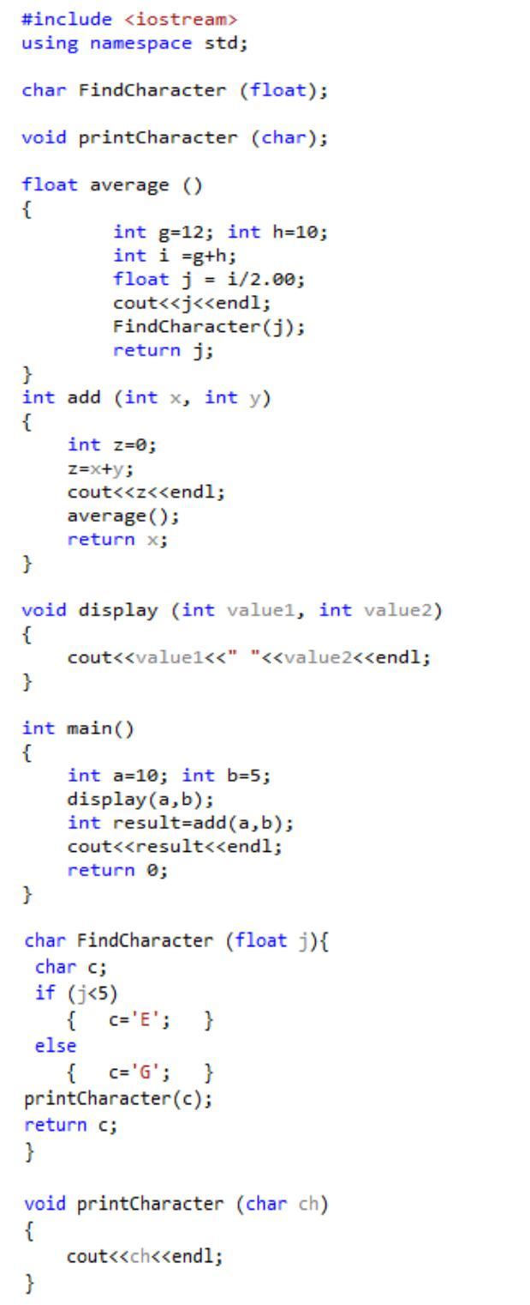

Output

10 5 15 11.00 G 10

